**Pengantar Statistik Sosial**



**Rahajeng Sekar Wangi Nugroho 071911633033**

**Rosidah Maharani Alfi Rahmah 071911633034**

**Yollanda Nundy Alshafa 071911633037**

**Dewi Sintawati 071911633038**

**Fatchorrahman Zain 071911633094**

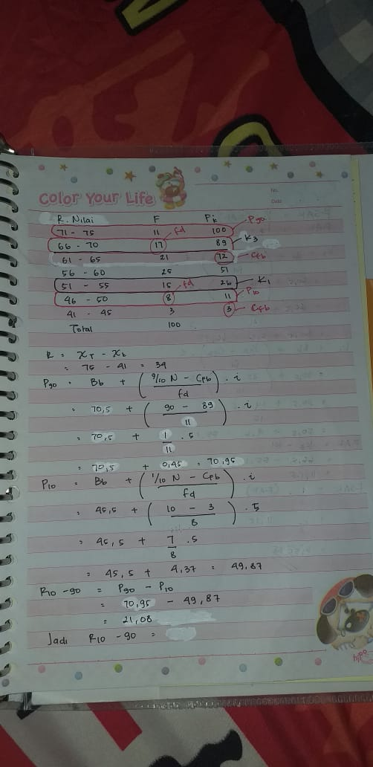

**1.**

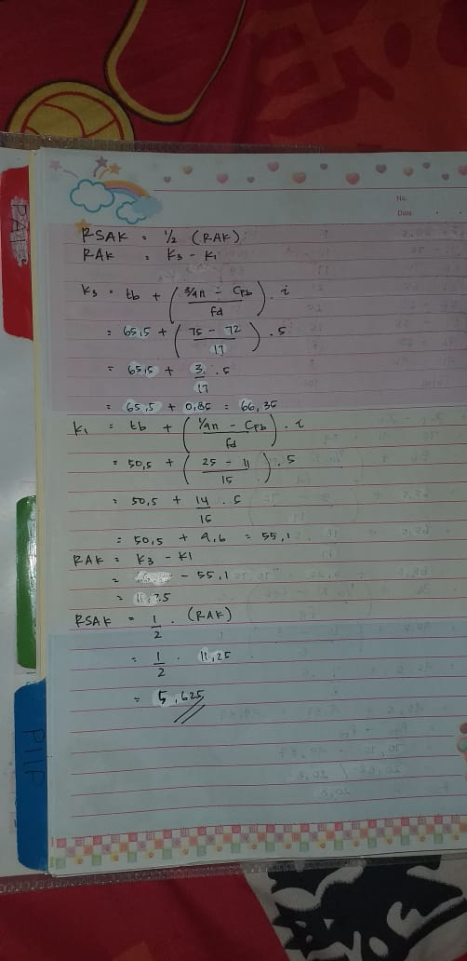

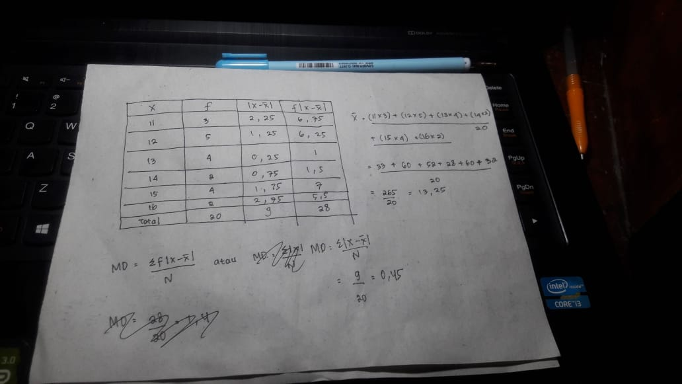

**2.**